C++ reference

A reference variable is a reference to an existing variable, and it is created with & operator.

|  |
| --- |
| #include <iostream>  using namespace std;  int main(){  int a;  int &b = a;    a = 5;  b = a;    cout <<"here a = "<<a<< "and b = "<<b<<endl;    return 0;  } |
|  |

|  |
| --- |
| #include <iostream>  using namespace std;  int main(){  string food = "Pizza";  string &f1 = food;  cout<<"food = "<< food<<endl;  cout<<"f1 = "<<f1<<endl;    return 0;  } |

C++ Memory address

Memory address also use ‘&’. We can get a variable’s address by using this.

|  |
| --- |
| #include <iostream>  using namespace std;  int main(){  int a;  a = 5;  cout<<"address of a is"<<&a <<endl;  } |

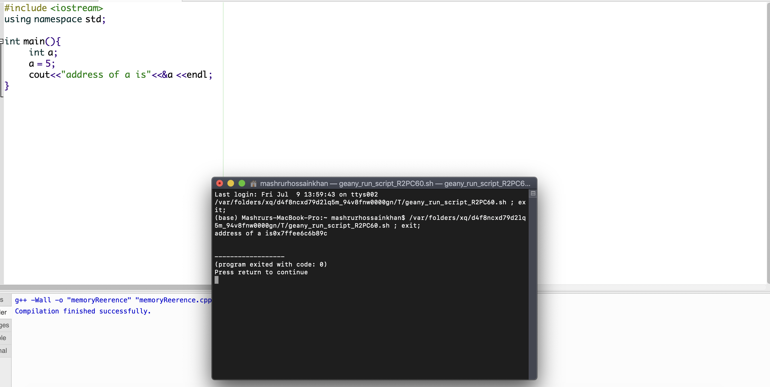

C++ pointer

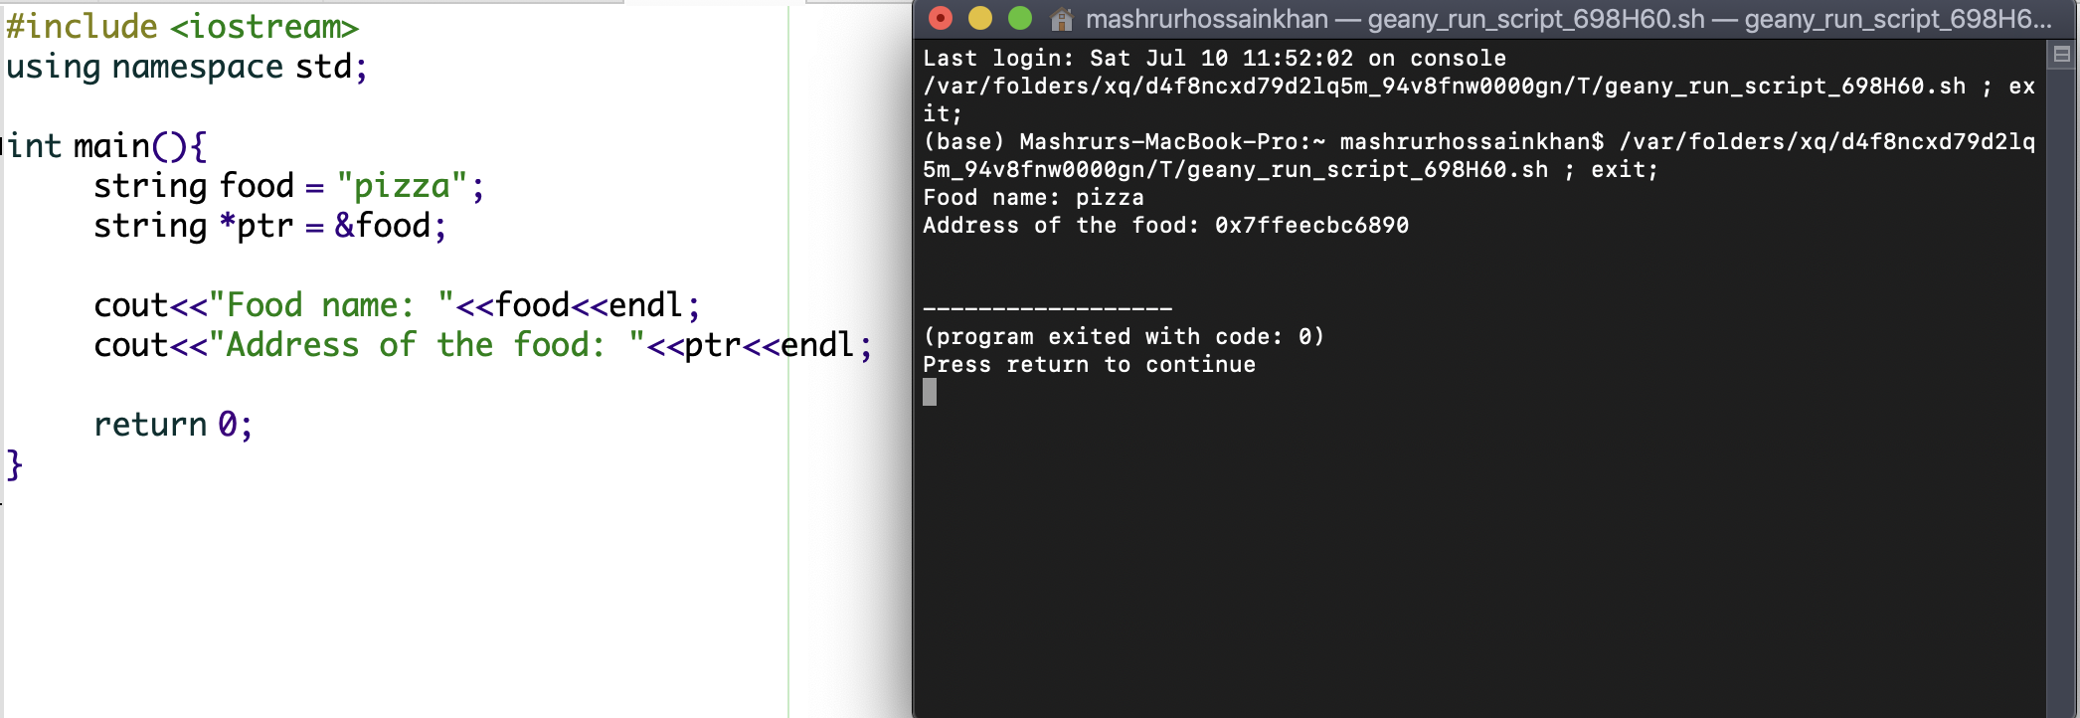

|  |
| --- |
| #include <iostream>  using namespace std;  int main(){  string food = "pizza";  string *ptr = &food;    cout<<"Food name: "<<food<<endl;  cout<<"Address of the food: "<<ptr<<endl;    return 0;  } |

here, ptr holds the memory address of food variable. When, we want to assign the memory address of a variable in another variable, we use pointer. Pointer keeps the address of another variable as its value.

C++ Dereference

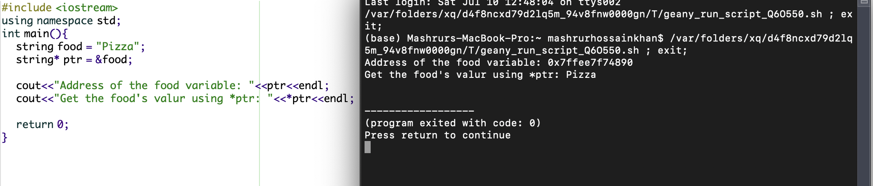

|  |
| --- |
| #include <iostream>  using namespace std;  int main(){  string food = "Pizza";  string* ptr = &food;    cout<<"Address of the food variable: "<<ptr<<endl;  cout<<"Get the food's value using *ptr: "<<*ptr<<endl;    return 0;  } |

We can get the value of the variable (not the address) using pointer

Modify pointer

Change the main variable name with the help of ptr.

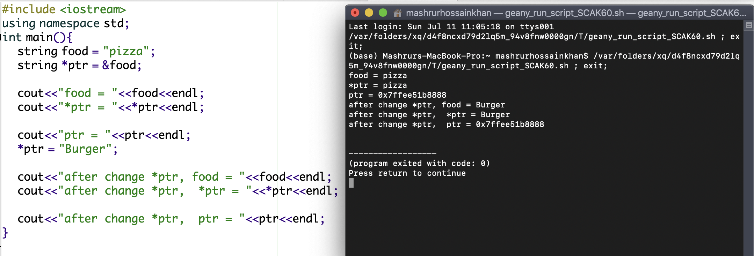

|  |
| --- |
| #include <iostream>  using namespace std;  int main(){  string food = "pizza";  string *ptr = &food;    cout<<"food = "<<food<<endl;  cout<<"*ptr = "<<*ptr<<endl;    cout<<"ptr = "<<ptr<<endl;  *ptr = "Burger";    cout<<"after change *ptr, food = "<<food<<endl;  cout<<"after change *ptr, *ptr = "<<*ptr<<endl;    cout<<"after change *ptr, ptr = "<<ptr<<endl;  } |

changing *ptr will change the variable food also.

# C++ Default Parameters

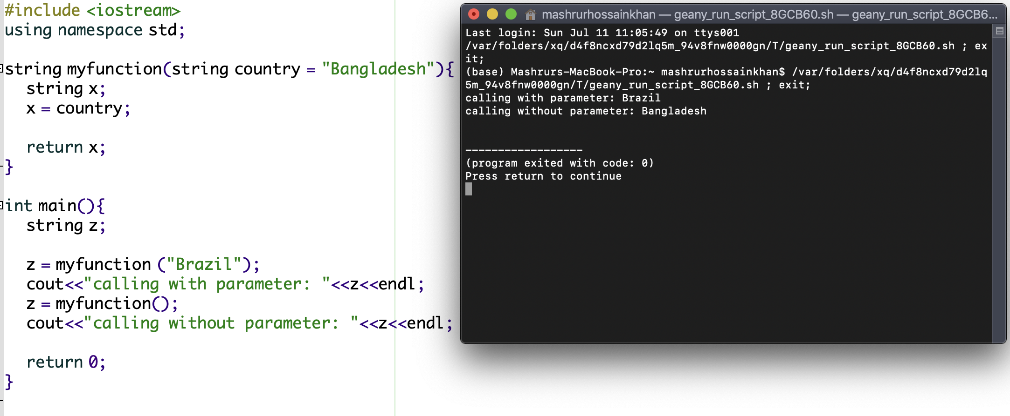

|  |
| --- |
| #include <iostream>  using namespace std;  string myfunction(string country = "Bangladesh"){  string x;  x = country;    return x;  }  int main(){  string z;    z = myfunction ("Brazil");  cout<<"calling with parameter: "<<z<<endl;  z = myfunction();  cout<<"calling without parameter: "<<z<<endl;    return 0;  } |

function: pass by reference

|  |
| --- |
| #include <iostream>  using namespace std;  void swapPassByReference (int &x, int &y){  cout<<"swapPassByReference address x = "<<&x<<" y = "<<&y<<endl;  int z = x;  x = y;  y = z;  }  void swapNotPassByReference (int x, int y){  cout<<"swapNotPassByReference address x = "<<&x<<" y = "<<&y<<endl;  int z = x;  x = y;  y = z;  }  int main(){  int firstNum = 10;  int secondNum = 20;    cout<<"before swap firstNum = "<<firstNum<<" and 2nd num = "<<secondNum<<endl;    swapNotPassByReference(firstNum, secondNum);  cout<<"address firstNum = "<<&firstNum<<" secondNum = "<<&secondNum<<endl;  cout<<"swapNotPassByReference: firstNumber = "<<firstNum<<" and second Number = "<<secondNum<<endl;    swapPassByReference(firstNum, secondNum);    cout<<"swapPassByReference: firstNumber = "<<firstNum<<" and second Number = "<<secondNum<<endl;  return 0;  } |

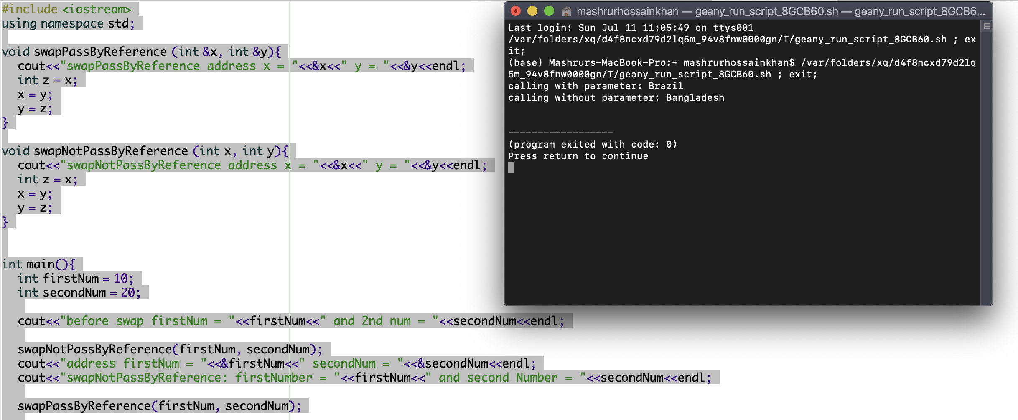

## **Function Overloading**

function name same but parameter can be different.

|  |
| --- |
| #include <iostream>  using namespace std;  int sum (int x, int y){  return x+y;  }  int sum (int x, int y, int z){  return x+y+z;  }  int main(){  int ans2, ans3;    ans2 = sum (1,2);  ans3 = sum (1,2,3);    cout<<"with 2 parameter: "<<ans2<<endl;  cout<<"with 3 parameters: "<<ans3<<endl;    return 0;  } |

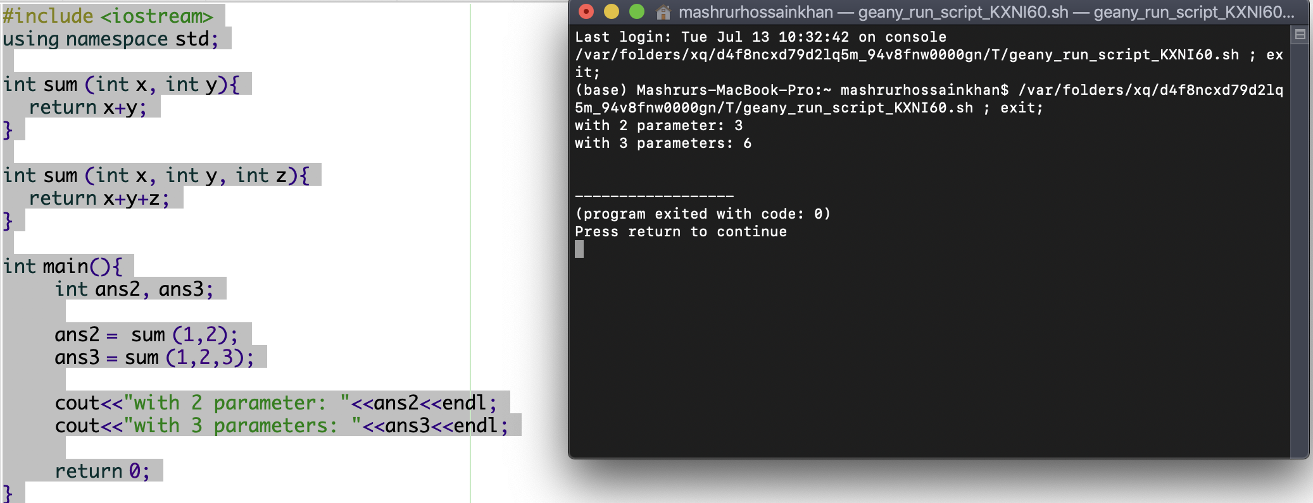

C++ oop

OOP = object-oriented programming.

Procedural programming is about the procedures and function which perform operations on data. On the other hand, OOP is about creating object that will contain data and functions as well.

OOP advantages:

1. reusability.
2. DRY code (Don’t repeat yourself).
3. Well-structured code.
4. Easier to debug and maintain.

Class is a template for an  
 object, on the Other hand object is an instance of a class. When a individual object is created it inherits all the variables and function.

code:

|  |
| --- |
| #include <iostream>  using namespace std;  class learn {  public:  string what;  string where;  };  int main(){  learn learn1;    learn1.what = "C++";  learn1.where = "W3school";    cout<<"Learnring "<<learn1.what<<" from "<<learn1.where<<endl;    return 0;  } |

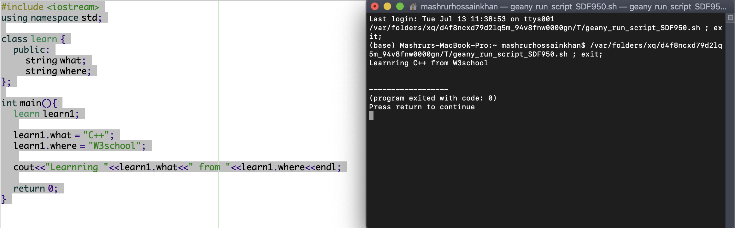

C++ methods

CODE:

|  |
| --- |
| #include <iostream>  using namespace std;  class Learn {  public:  //inside method  void next(){  cout<<"next is JS"<<endl;  }    //outside method  void next1();    //with parameter    void next2 (string what){  cout<<"next "<<what<<endl;  }  };  void Learn :: next1(){  cout<<"Next is JS"<<endl;  }  int main(){  Learn JS;    JS.next();  JS.next1();  JS.next2("JS");  } |

Methods are functions which are written inside of a class.

there are two kinds of methods in c++. 1) inside method and 2) outside methods. Methods can be also used with parameters.

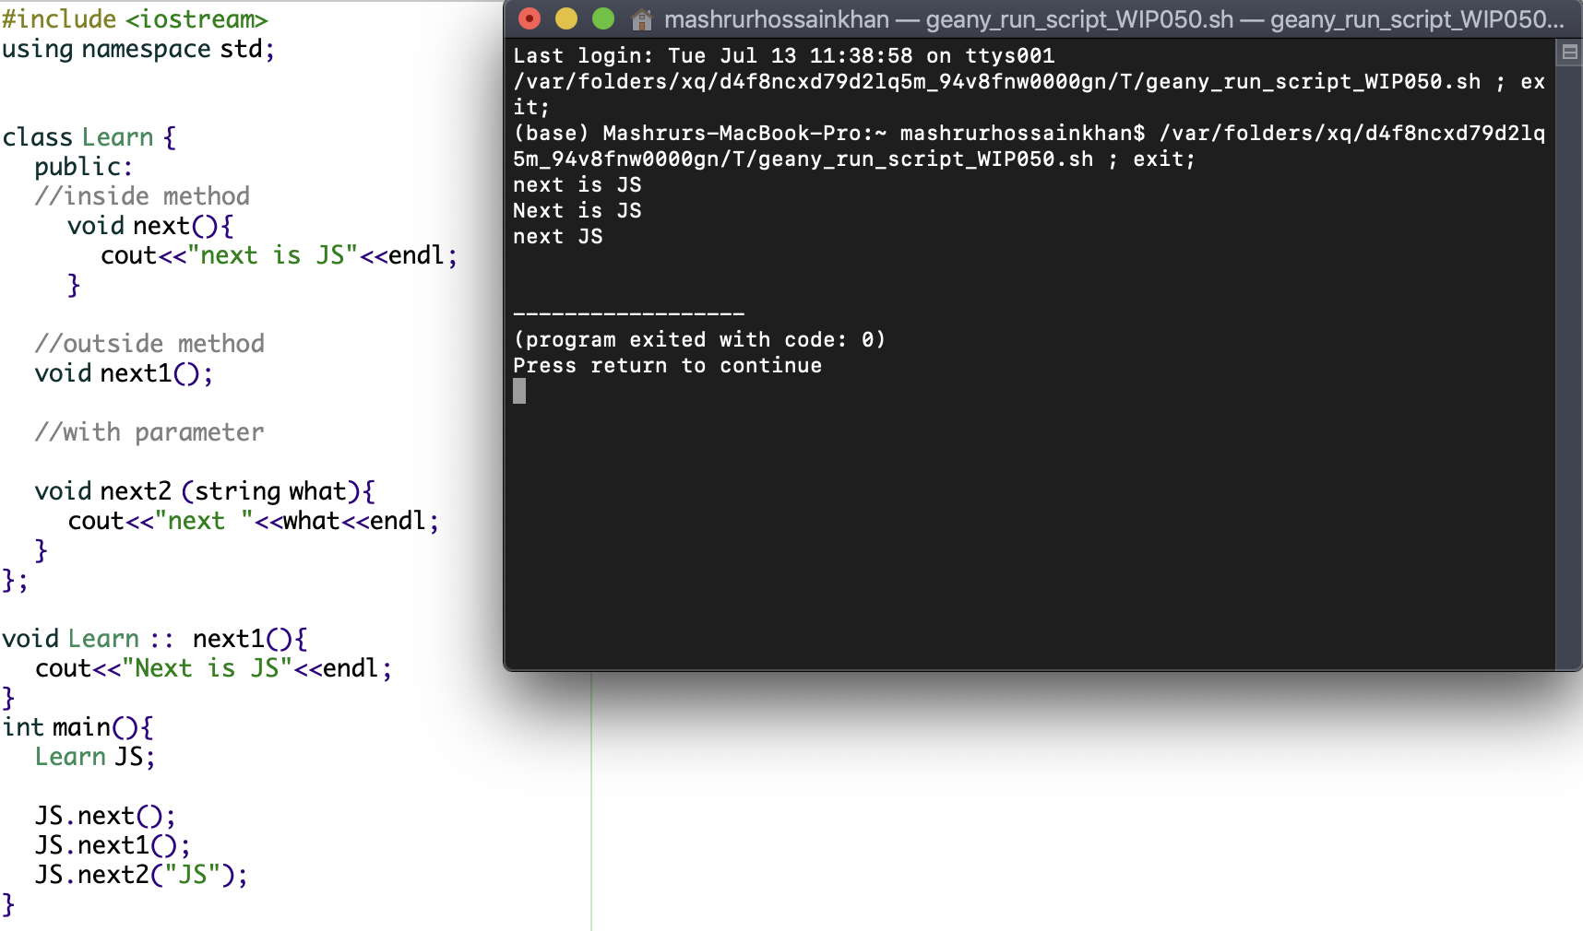

C++ constructor

|  |
| --- |
| #include <iostream>  using namespace std;  class learn{  public:  learn1() {  cout<<"We are learning "<<"js"<<endl;  }  };  int main(){  learn learn1;  } |

the name of the function is same as the class name. And it is called when an object is created.

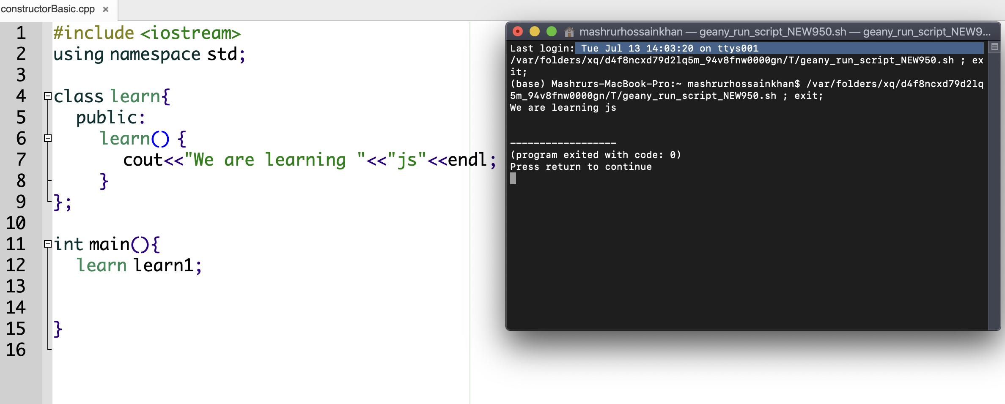

Constructor with parameter

|  |
| --- |
| #include <iostream>  using namespace std;  class learn{  public:  learn (string x){  cout<<"I am learning "<<x<<endl;  }  };  int main(){  learn learn1("C++");  } |

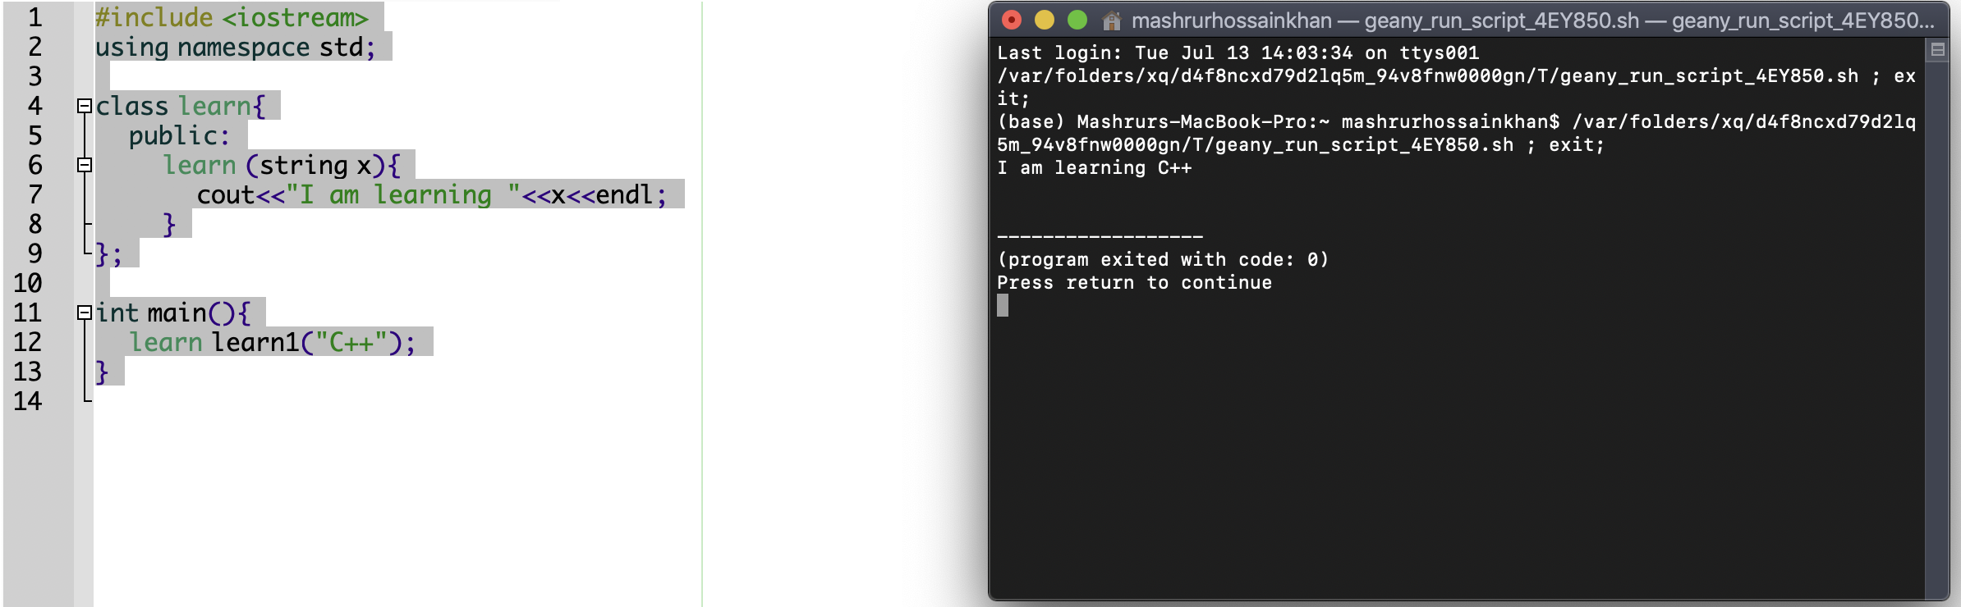

Constructor outside

|  |
| --- |
| #include <iostream>  using namespace std;  class learn{  public:  learn();  };  learn::learn(){  cout<<"I am learning C++"<<endl;  }  int main(){  learn learn1;  } |

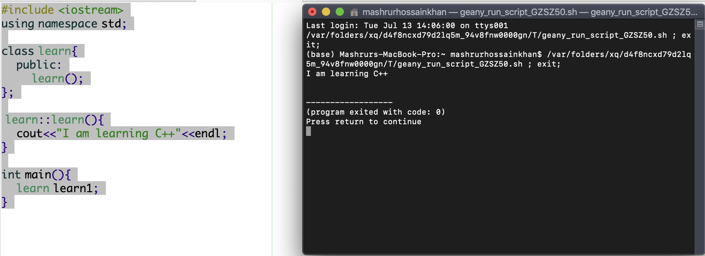

C++ access specifier

1. public
2. private: cannot be accessed from outside of the class.
3. protected: cannot be accessed from outside of the class, but can be accessed in inherited classes.

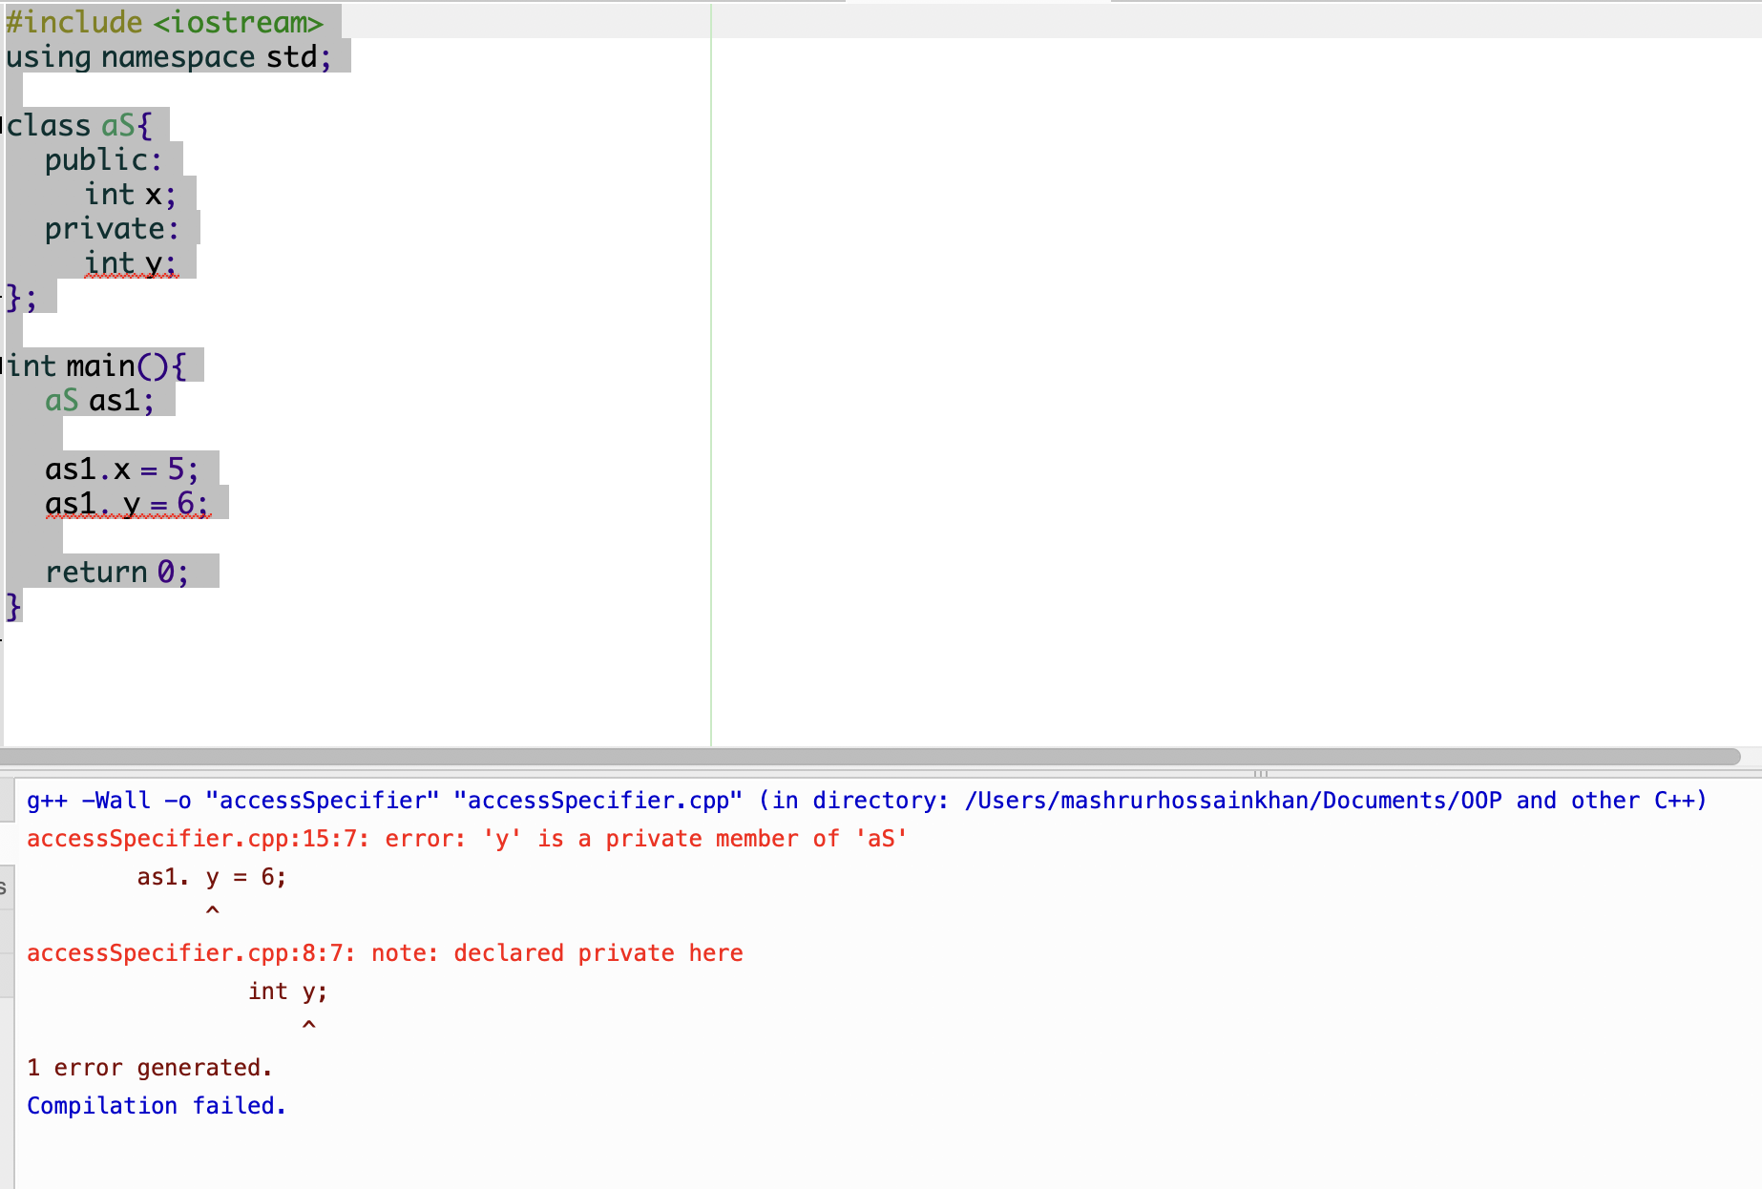

|  |
| --- |
| #include <iostream>  using namespace std;  class aS{  public:  int x;  private:  int y;  };  int main(){  aS as1;    as1.x = 5;  as1. y = 6;    return 0;  } |

Encapsulation

Encapsulation is a good practice. Because, it is good to declare your class attributes as private. Encapsulation ensures better control on the data. Using encapsulation provides more security.

In encapsulation, the main data is private, but we write set and get method to give the customers the opportunities to operate on the data.

|  |
| --- |
| #include <iostream>  using namespace std;  class bank{  private:  int money;    public:  void setMoney(int x){  money = x;  }    int getMoney(){  return money;  }  };  int main(){  bank customer1;  int total = 0;    customer1.setMoney (10000);  total = customer1.getMoney();    cout<<"Money: "<<total<<endl;    return 0;  } |

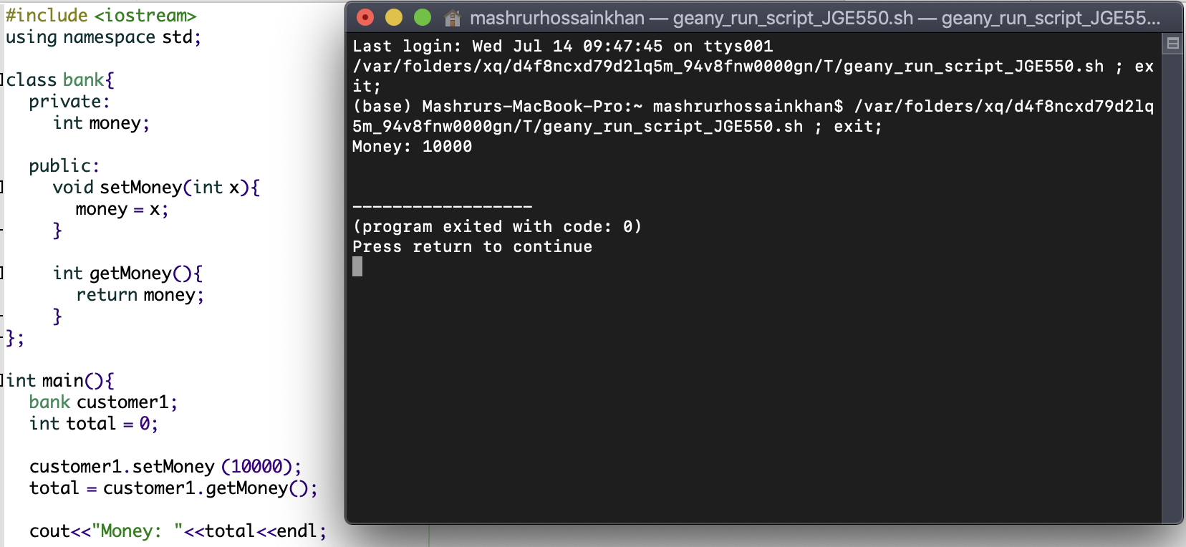

Inheritance

Inheritance inherits another class. The main class is called parent or based class, on the other hand another class is called derived class. Inherits increase the usability of code. If we have class named car, we can inherit car class and write derived class like Toyota, sonata, Audi, BMW etc.

|  |
| --- |
| #include <iostream>  using namespace std;  class car{  public:  int wheel;  int doors;  };  class audi : public car{  public:  int camera;  };  int main(){  audi audi1;    audi1.wheel = 4;  audi1.doors = 4;  audi1.camera = 1;    cout<<"wheel: "<<audi1.wheel<< "Door: "<<audi1.doors<<"Camera: "<<audi1.camera<<endl;    return 0;  } |

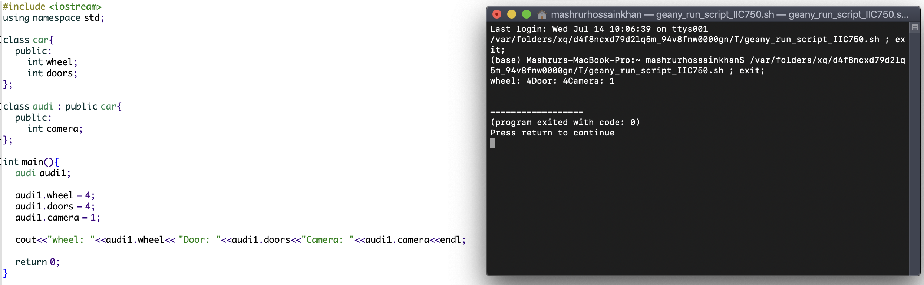

Multilevel inheritance

myClass -> myChild -> myGrandChild

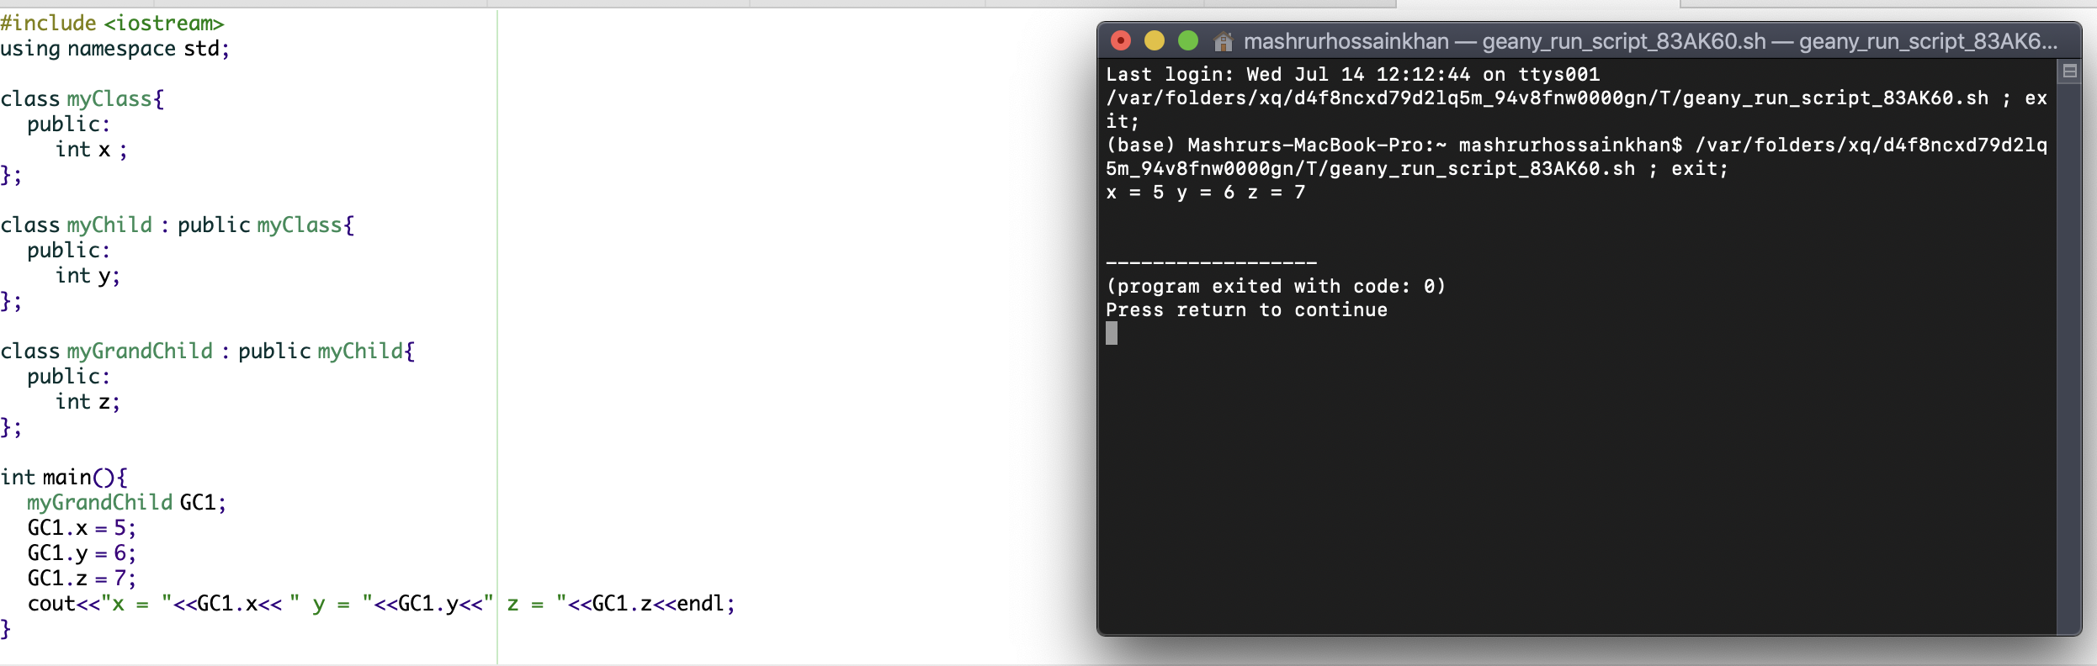

|  |
| --- |
| #include <iostream>  using namespace std;  class myClass{  public:  int x ;  };  class myChild : public myClass{  public:  int y;  };  class myGrandChild : public myChild{  public:  int z;  };  int main(){  myGrandChild GC1;  GC1.x = 5;  GC1.y = 6;  GC1.z = 7;  cout<<"x = "<<GC1.x<< " y = "<<GC1.y<<" z = "<<GC1.z<<endl;  } |

Multiple inheritance

a class can be derived from more than one class, separated with comma. here, class c is derived from a and b class.

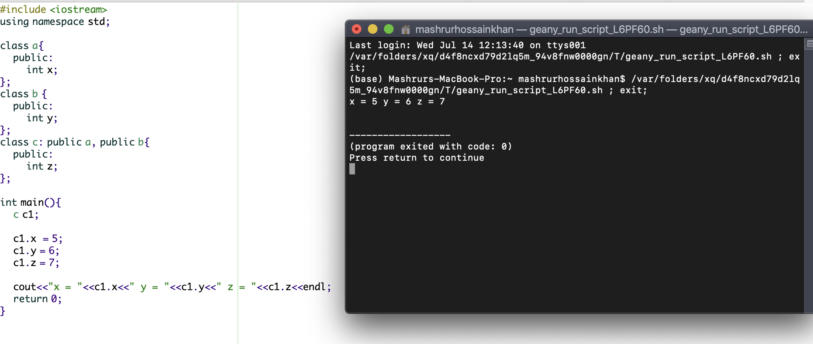

|  |
| --- |
| #include <iostream>  using namespace std;  class a{  public:  int x;  };  class b {  public:  int y;  };  class c: public a, public b{  public:  int z;  };  int main(){  c c1;    c1.x = 5;  c1.y = 6;  c1.z = 7;    cout<<"x = "<<c1.x<<" y = "<<c1.y<<" z = "<<c1.z<<endl;  return 0;  } |

C++ inheritance access

protected is used to access private data of parent class.

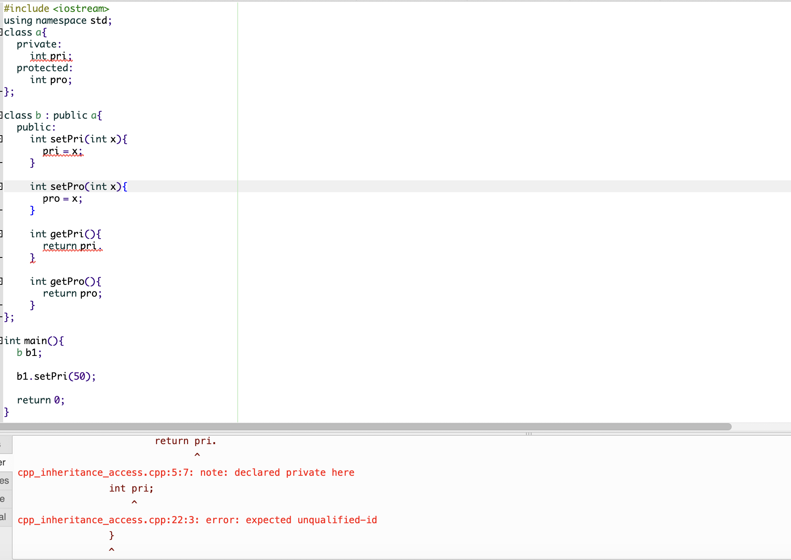

private is not accepted.

|  |
| --- |
| #include <iostream>  using namespace std;  class a{  protected:  int pro;  };  class b : public a{  public:  void setPro(int x){  pro = x;  }  int getPro(){  return pro;  }  };  int main(){  b b1;    b1.setPro(50);    int z;  z = b1.getPro();    cout<<"The value using protected: "<<z<<endl;  return 0;    return 0;  } |

same code using private:

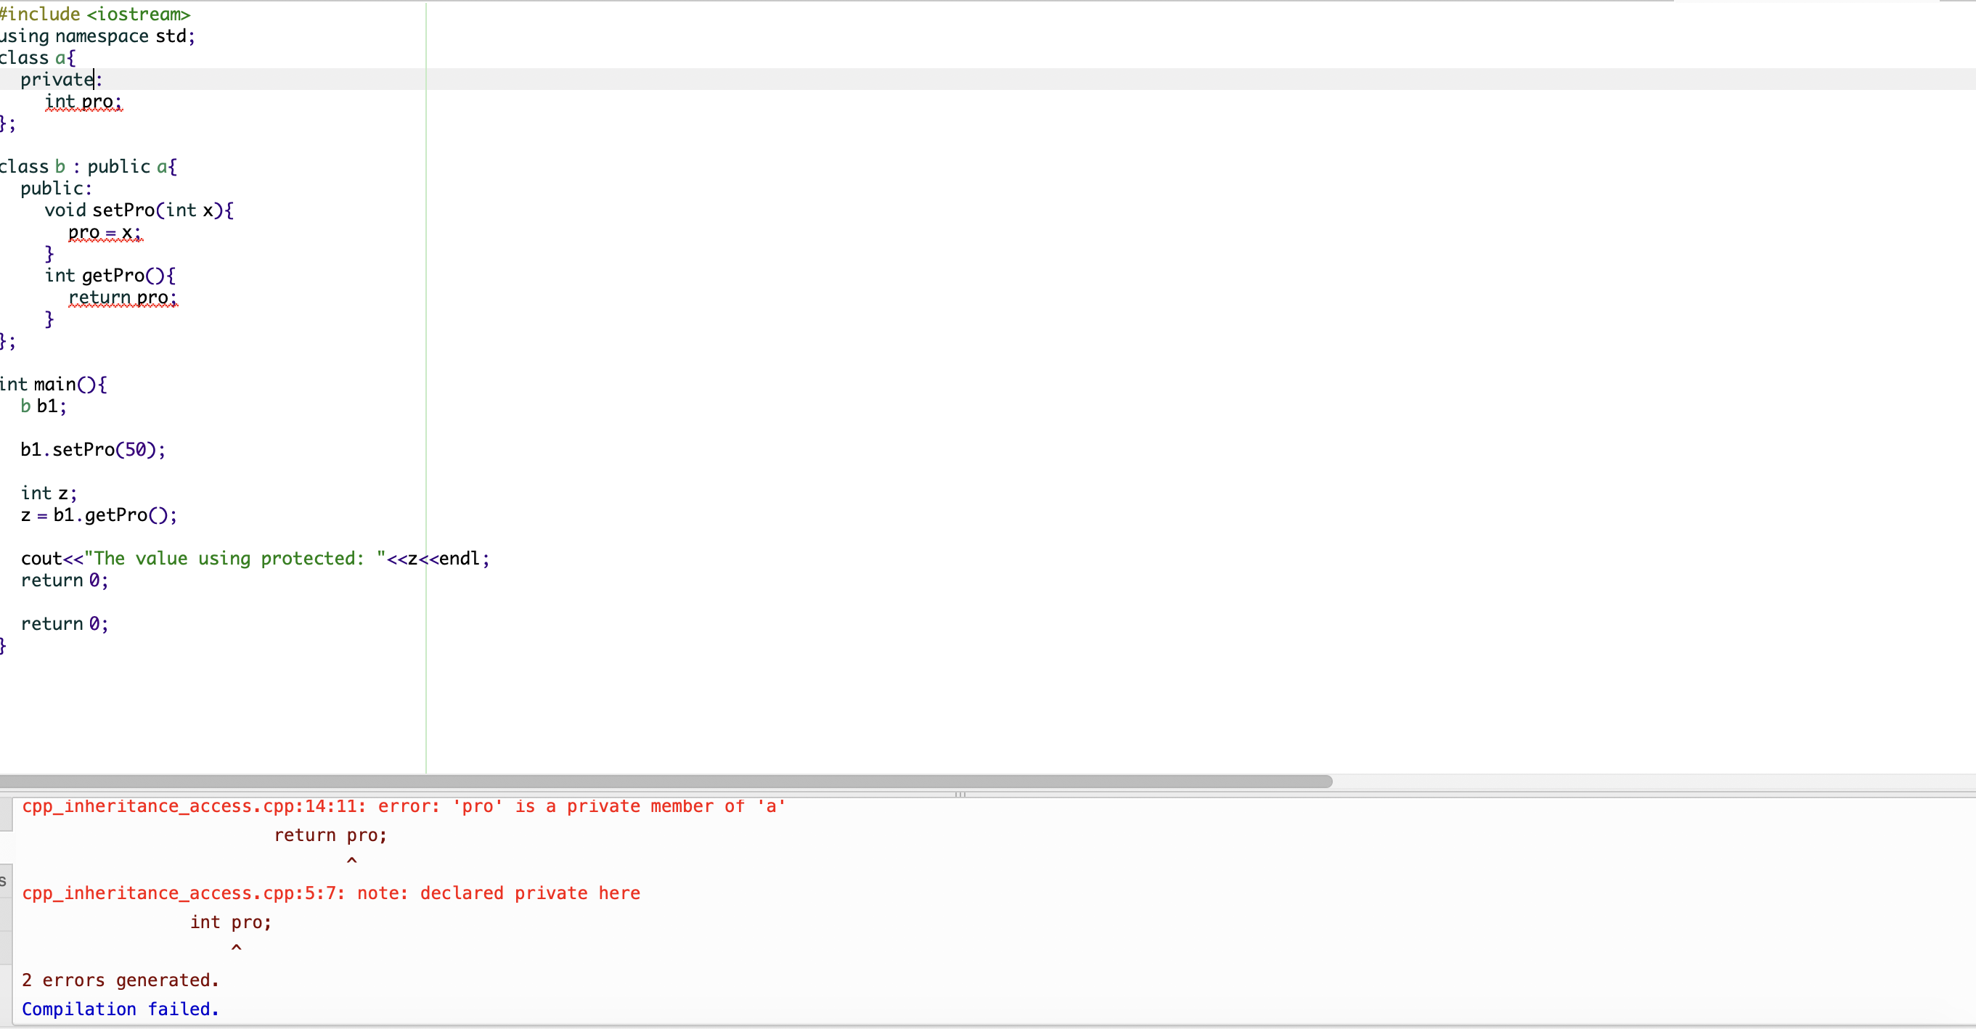

Polymorphism

one parent class and several derived classes.

|  |
| --- |
| #include <iostream>  using namespace std;  class animal{  public:  void sound(){  cout<<"animals make sound!"<<endl;  }  };  class dog : public animal{  public:  void sound(){  cout<<"Dogs say: bhew bhew"<<endl;  }  };  class cat : public animal{  public:  void sound(){  cout<<"Cats say: Meow"<<endl;  }  };  int main(){  cat cat1;  animal animal1;  dog dog1;    cat1.sound();  animal1.sound();  dog1.sound();    return 0;  } |

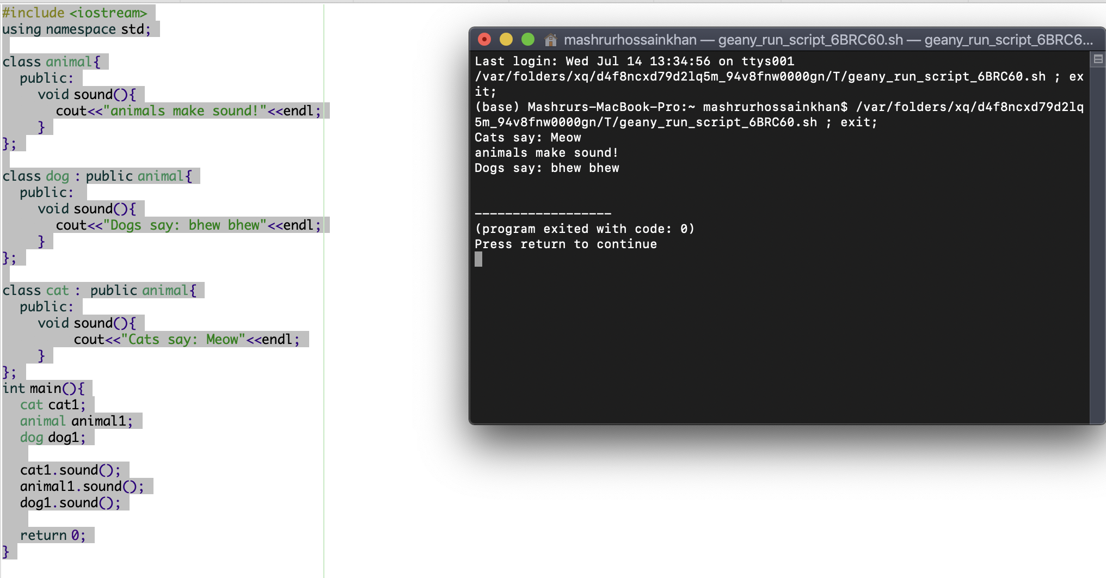

C++ exception

Errors are made by programmers. errors can be controlled with try….catch. Again, errors can be made due to wrong input and unforeseeable things.

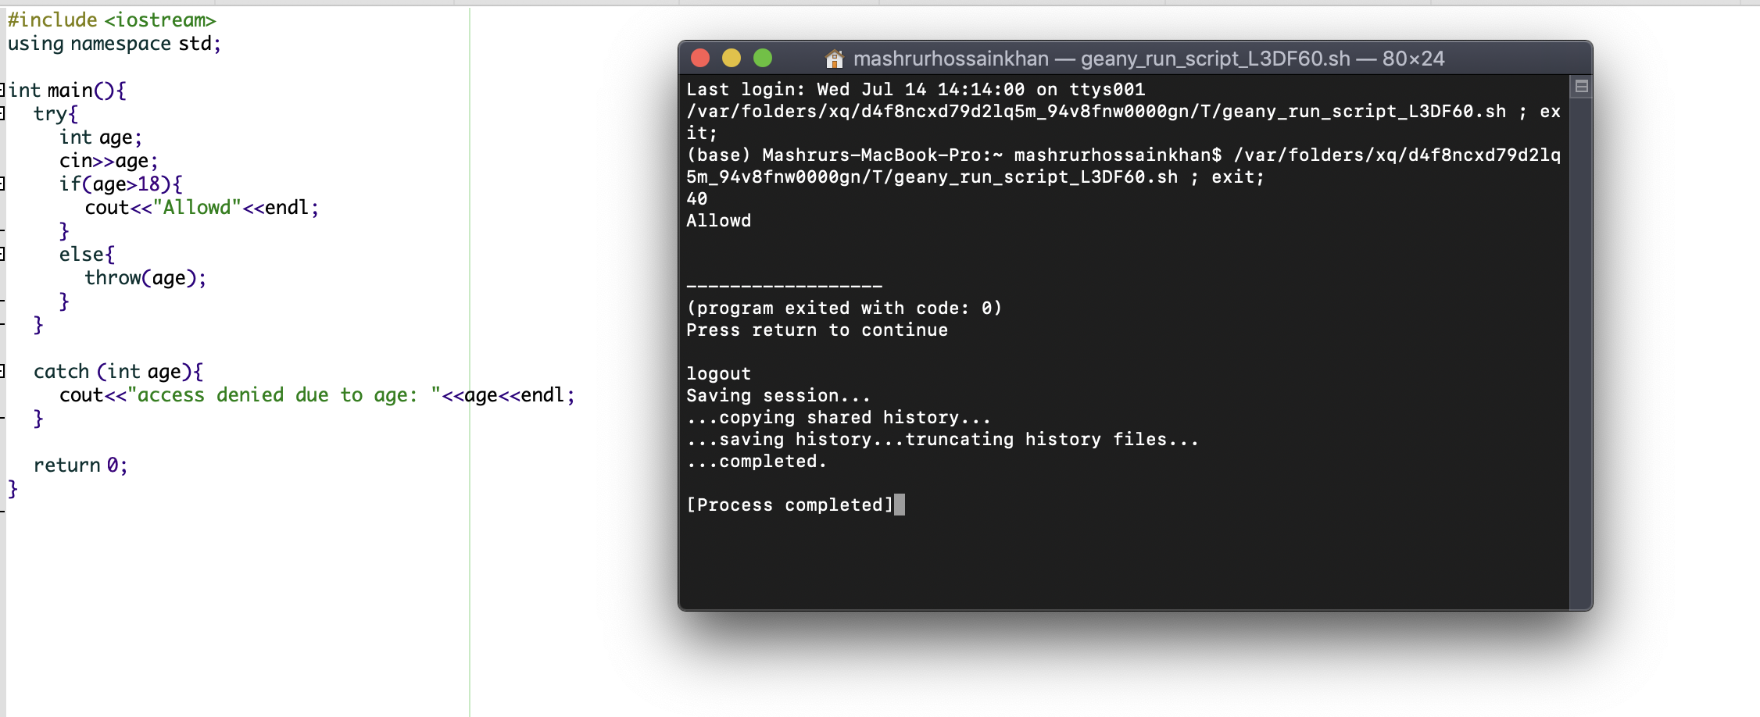

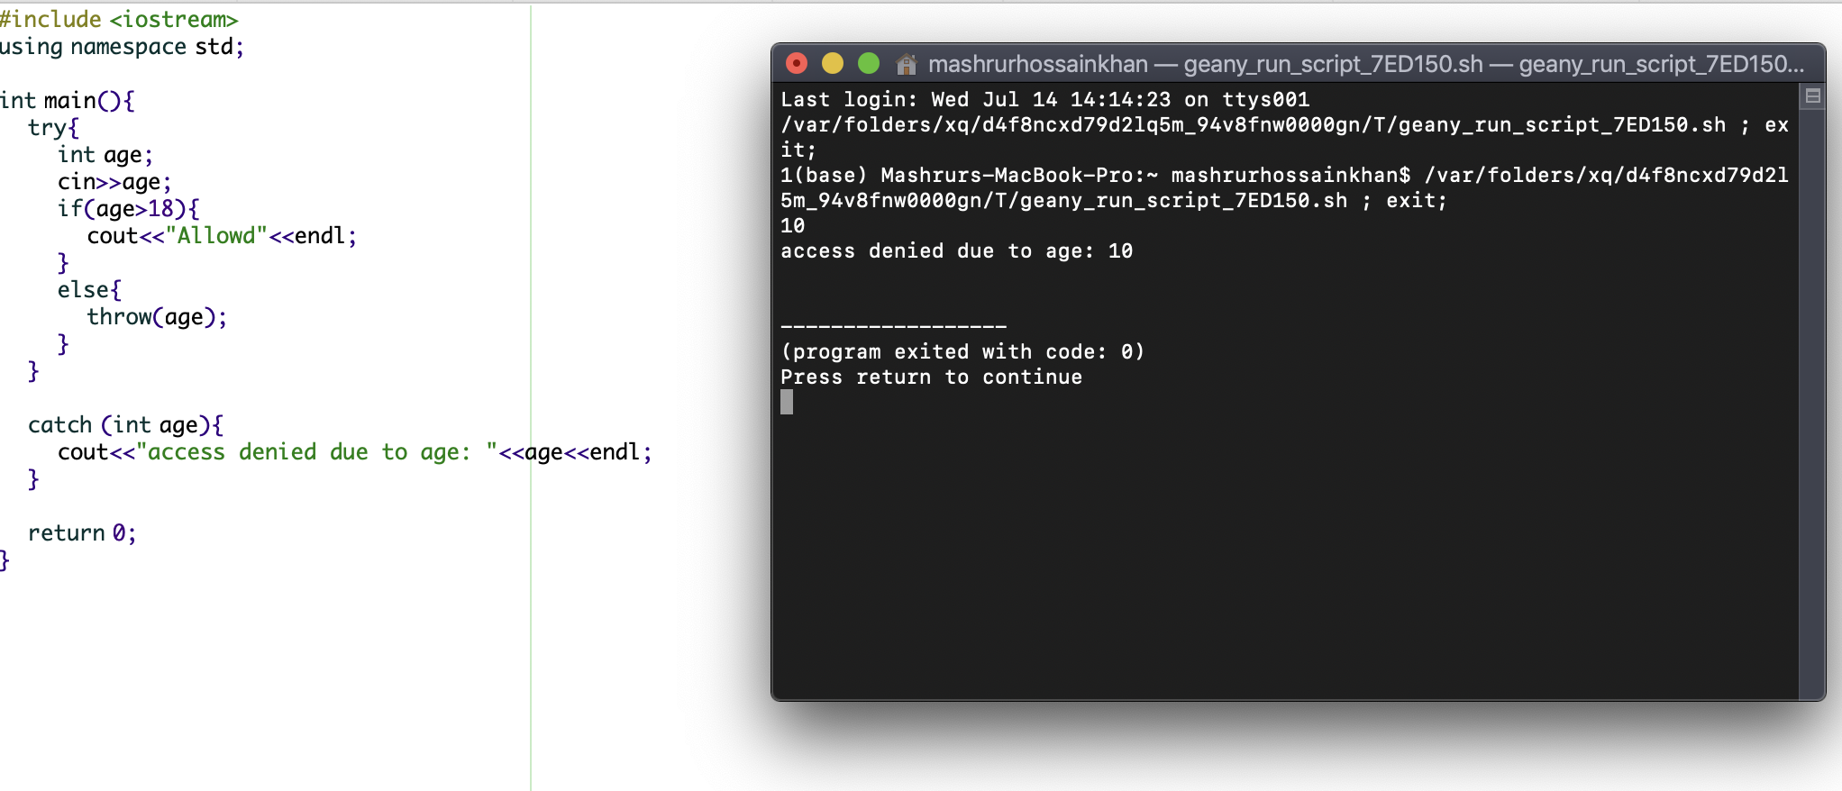

|  |
| --- |
| #include <iostream>  using namespace std;  int main(){  try{  int age;  cin>>age;  if(age>18){  cout<<"Allowd"<<endl;  }  else{  throw(age);  }  }    catch (int age){  cout<<"access denied due to age: "<<age<<endl;  }    return 0;  } |